Gender Review Behaviour on YELP By Mary-Jane, Tomislav, Aukje

December 4th, 2019

The goal of this project was to discover if there are significant differences between men and women in the way they rate restaurants on YELP. Digging a bit deeper, we tried to find a corrolation between mean household income vs the type of restaurants and their overall ratings by geographical location (zip code).

The answer to these questions may help restaurants better target their audience.

The project is split up in 3 sub-questions:

* + Q1: Are men and women perceived differently by their peers and who reviews more often
  + Q2: Do men review restaurants differently from women when it comes to the type of restaurants they review (cheap to expensive) and the ratings they give (1 to 5 stars)
  + Q3: How is review behavior related to local economic factors (avg household income/ZIP)

To answer these questions several flat file downloads were used (both .json and .csv files) as well as YELP and Census API’s. The chart below describes the process. Jupyter notebook was used to retrieve, manipulate, graph and analyse the data.

the review rating they assign (women rate ‘higher’)

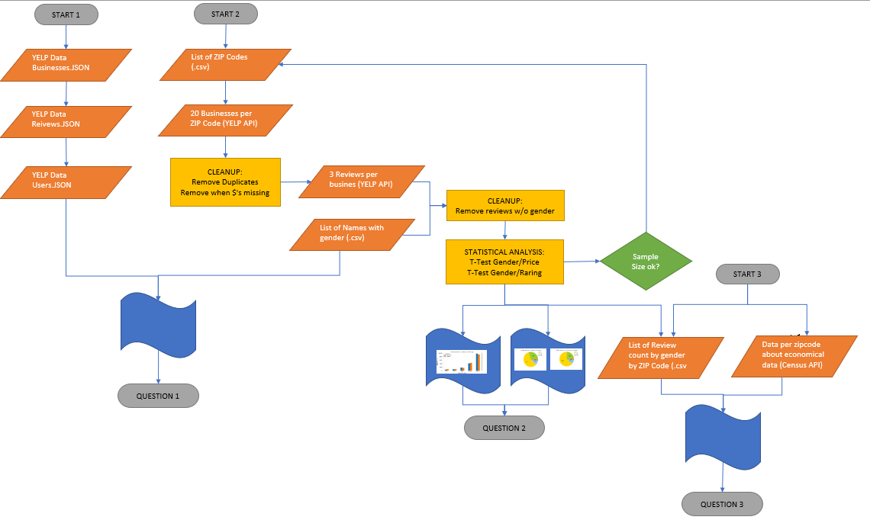

T-tests were run on all results to establish relevance to the hypothosis.

The main conclusions that can be drawn:

* Female reviewers have more fans, they receive more ‘useful’ ratings and they review significanly more restaurants then men. Restaurants may be wise to target women over men.
* The online (API) results confirmed that women are more active reviewers then men. It also showed a significant difference  between men and women in the type of restaurants they rate (men rate more $ and women more $$ restaurants – implying they might eat at cheaper place then women) and how they rate (women tend to give more 1 and 5 start reviews, where the spread between men is divided more evenly – implying women are more resolute in the review behaviour.
* Lastly analysis showed a clear correlation between the average price of a restaurant within a zipcode and the mean household income in that same zip code. Men vs Women….